

DEPARTMENT OF COMPUTER SCIENCE AND ENGINEERING

CS23432 – Software Construction
(REGULATION 2023)
RAJALAKSHMI ENGINEERING COLLEGE
Thandalam, Chennai-602015

Name: Prithika S
Register No: 240701400
Year / Branch / Section: II / CSE
Semester: IV
Academic Year: 2025 - 2026

INDEX
S.No. | Date | Title
1. | 07-02-2026 | Jira Environment Setup.
2. | 14-02-2026 | Jira Project Setup and User Story Management.
3. | 21-02-2026 | Setting Up Epics, Tasks, And User Stories for Project Planning.
4. | 28-02-2026 | Sprint Planning in Jira.
5. | 07-03-2026 | Poker Estimation using Jira.
6. | 14-03-2026 | Designing Class and Sequence Diagrams.
7. | 04-04-2026 | Designing Architectural and ER Diagrams.
8. | 11-04-2026 | Testing – Test Suites and Test Cases in Jira.
9. | 18-04-2026 | Load Testing and CI/CD Pipeline Setup.
10. | 25-04-2026 | GitHub: Project Structure & Naming Conventions.

EXP NO: 01
JIRA ENVIRONMENT SETUP

Create Epic, Features, User Stories, Task

Aim:
To set up and access the Jira environment by creating an account and workspace for project management.

INSTALLATION
1.Open your web browser and go to the Jira website: https://www.atlassian.com/software/jira.
Sign in using your Atlassian account credentials.
If you don't have a Atlassian account, create a new account using the Sign Up option.
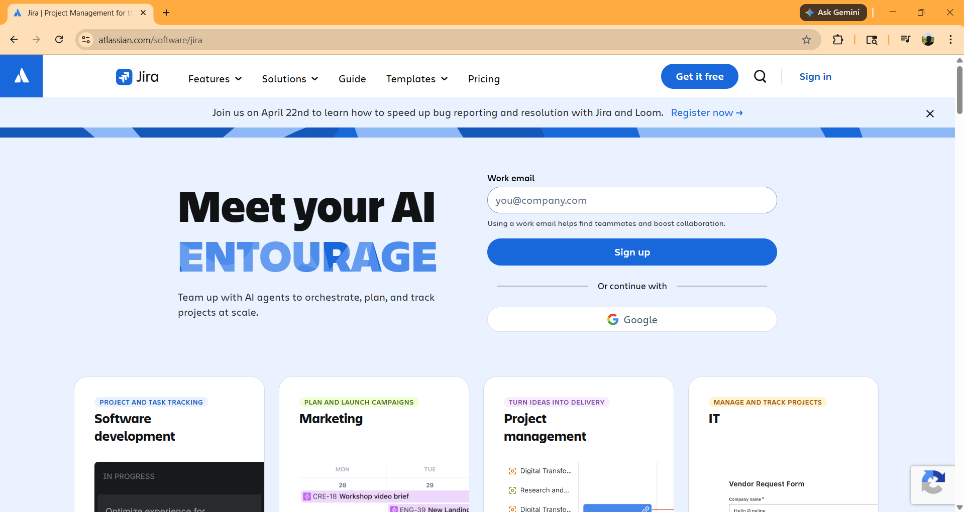

2.Jira home page
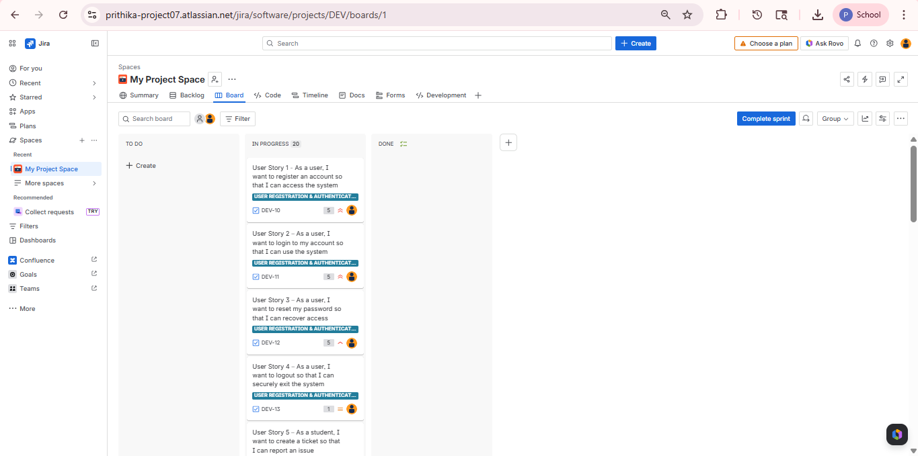
3. Open the Jira environment by typing Jira in the browser search bar or directly visiting https://www.atlassian.com/software/jira and sign in to access your workspace.
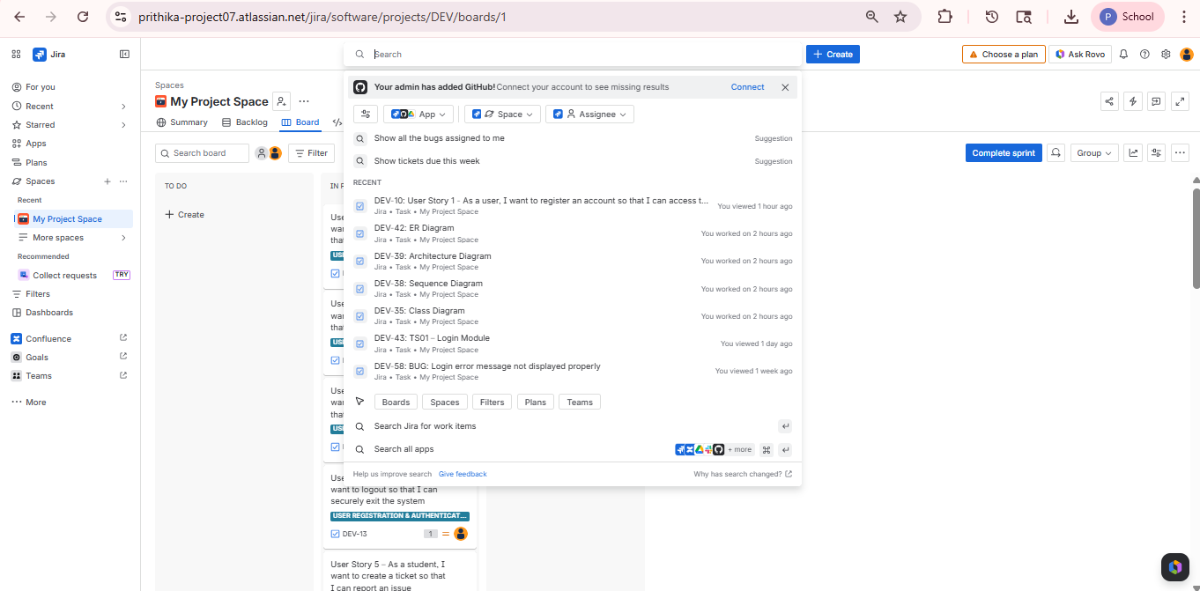

4. Click on the Create option in Jira, create a new site/workspace, and access the Jira project home page successfully.
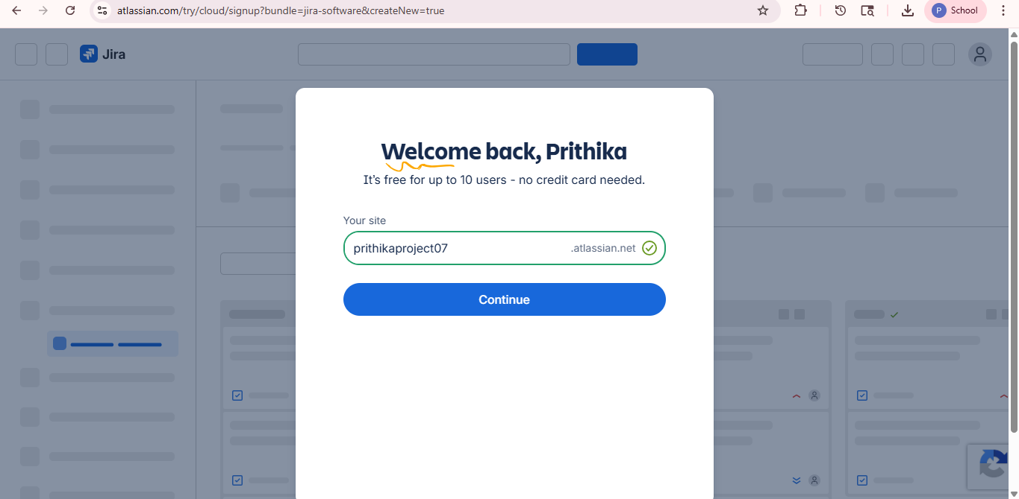

Result:
Successfully accessed the Jira environment and created a new workspace/site for project management.

EXP NO: 02
JIRA PROJECT SETUP AND USER STORY MANAGEMENT

Create Epic, Features, User Stories, Task

Aim:
To set up a Jira project for efficient collaboration and agile work management.

1. Create a Jira Account

2. Create the First Project in Your Workspace
a. After the Jira workspace is set up, you’ll need to create your first project. This is where tasks, user stories, sprints, and team activities will be managed.
b. On the Jira Home page, click on the Create Project button.
c. Enter the project details:
Name: Choose a name for the project (e.g., Customer Support Ticket Management System).
Description: Optionally, add a description to provide more context about the project.
Template: Select Scrum or Kanban template based on project needs.
Access: Choose whether the project should be Private or Open to team members.
d. Once all details are entered, click Create to set up your first Jira project.
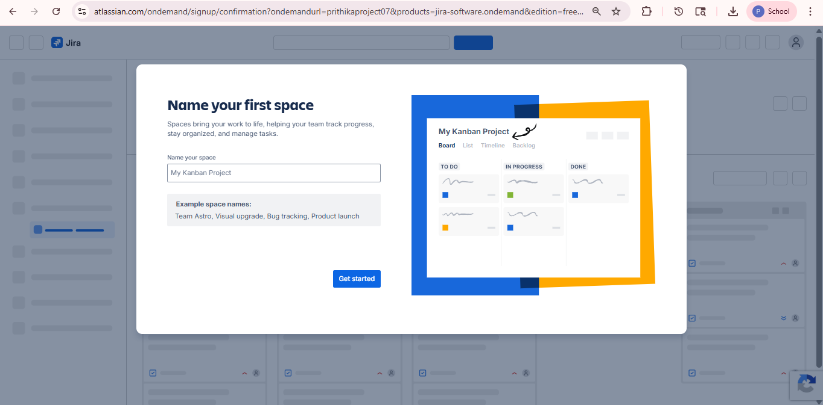

3. Once logged in, ensure you are in the correct Jira workspace. If you are part of multiple workspaces, you can switch between them from the left sidebar or project menu. Click on the project name to open the Jira project dashboard.

4. Project dashboard
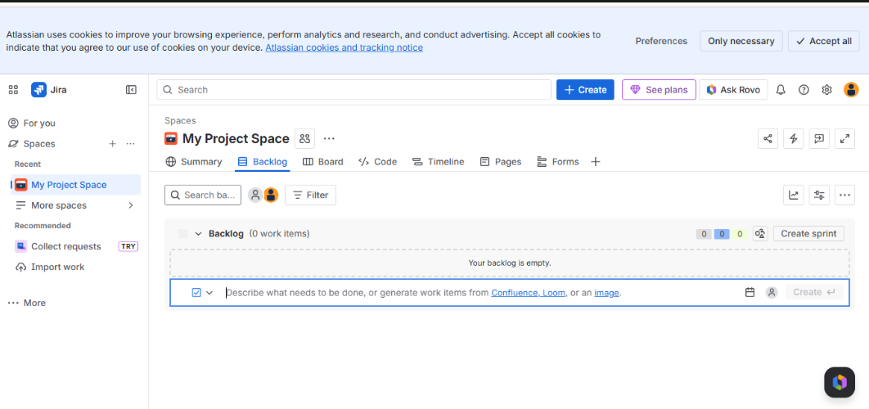

5. To manage user stories:
a. From the left-hand navigation menu, click on Backlog. This will open the Jira backlog page where user stories, tasks, and sprints can be managed.
b. On the backlog page, click the Create button or + Create Issue option. Select Story as the issue type and enter the details of the User Story.



Result:
Successfully created a Jira project with user story management and agile workflow setup

EXP NO: 03
EXP NO: 3
SETTING UP EPICS, TASKS, AND USER STORIES FOR PROJECT PLANNING

Create Epic, Features, User Stories, Task

Aim:
To learn about how to create epics, tasks, user stories, and backlogs for your assigned project.
Create Epic, User Stories, Task
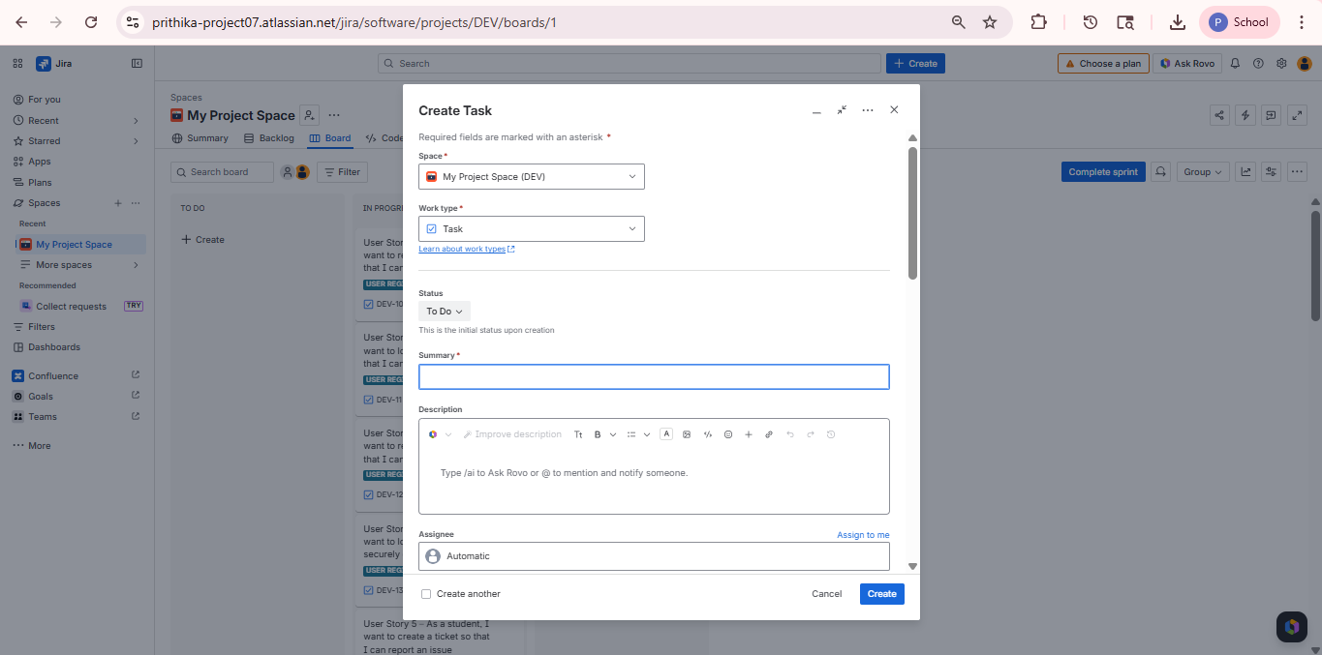
1.Fill in Epics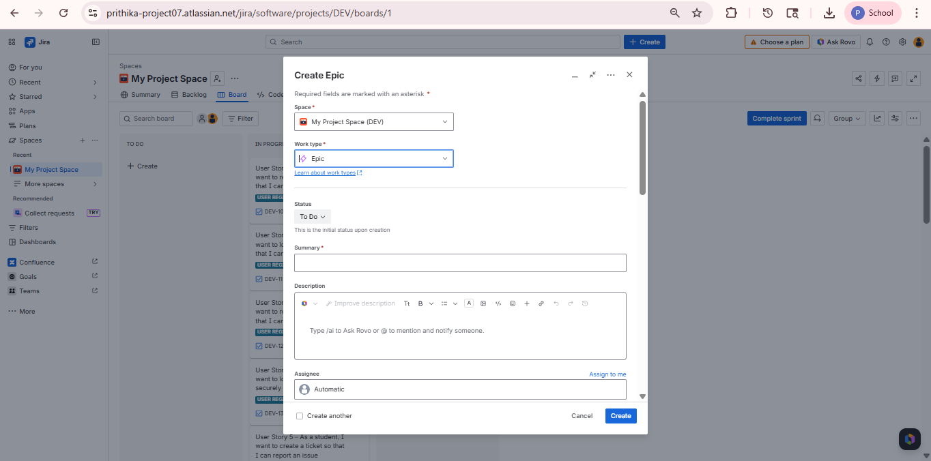

2.Fill in Features
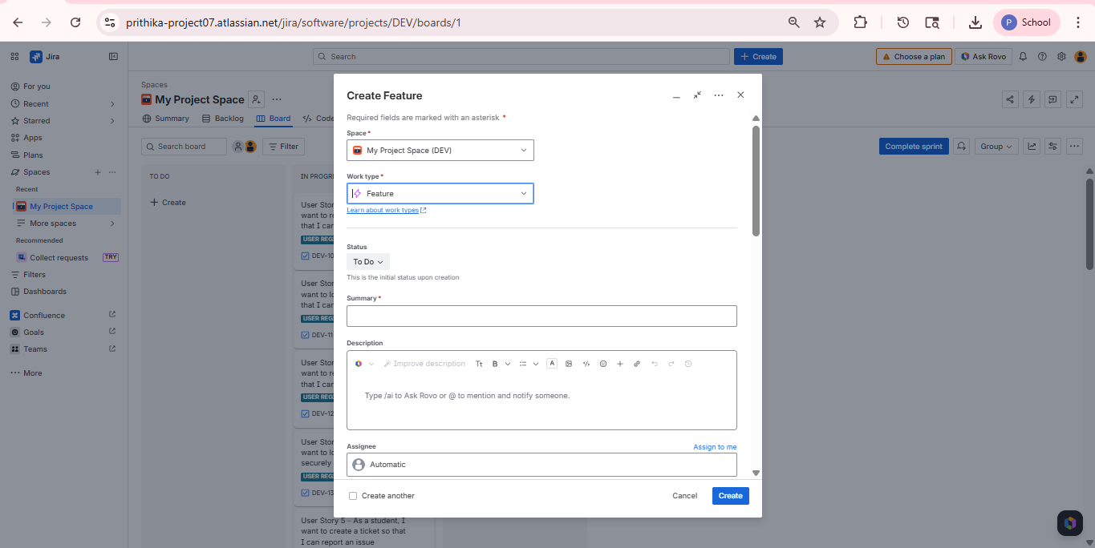

3.Fill in User Story Details
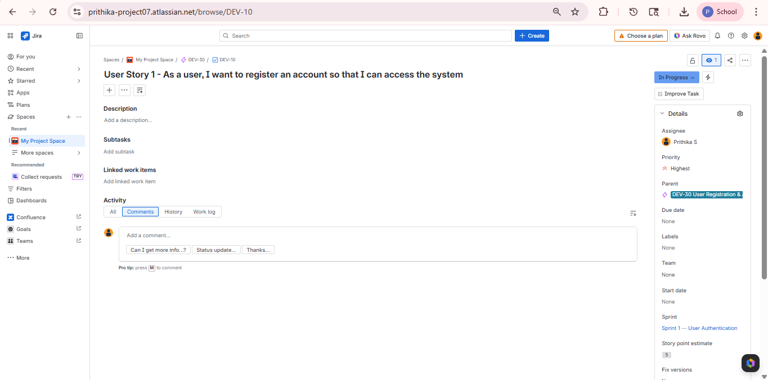

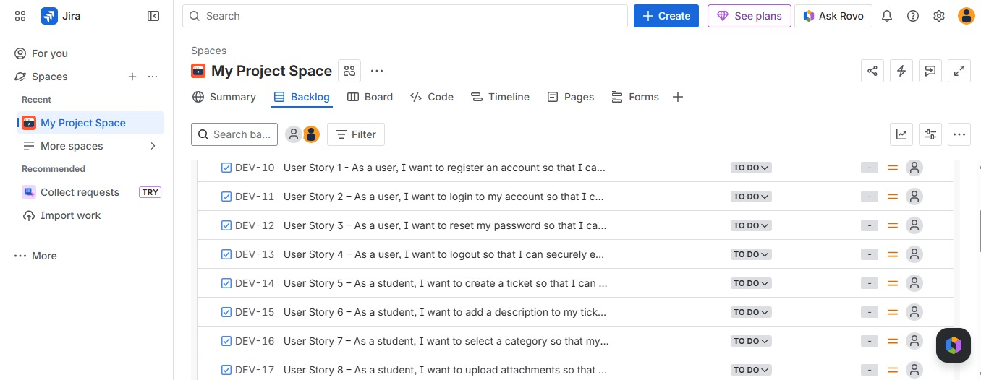

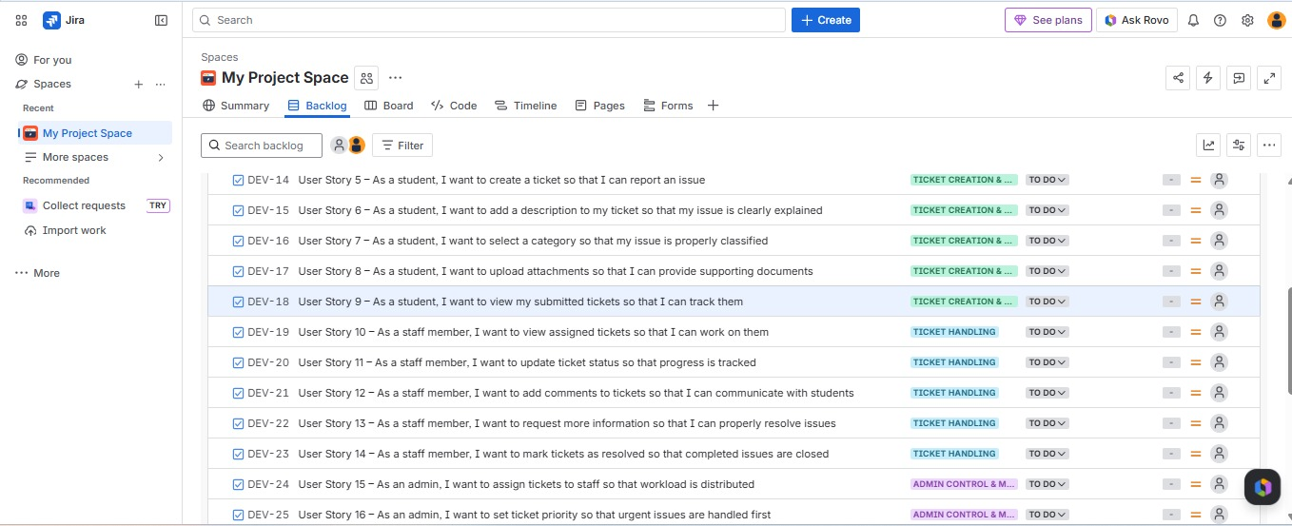

Result:
Thus, the creation of epics, features, user story and task has been created successfully.
EXP NO: 04
EXP NO: 4
SPRINT PLANNING IN JIRA

Create Epic, Features, User Stories, Task

Aim:
To assign user story to specific sprint for the Customer Support Ticket Management System Project.

Sprint Planning
Sprint 1
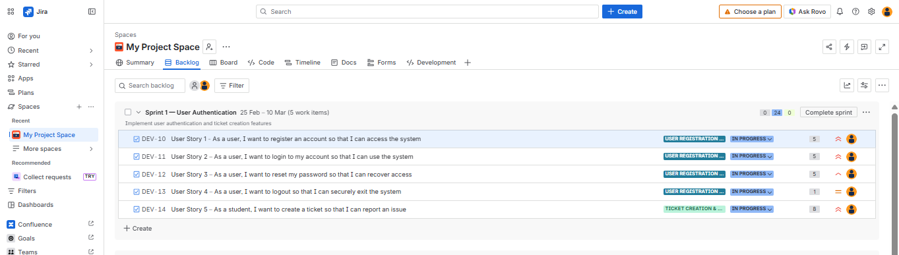

Sprint 2 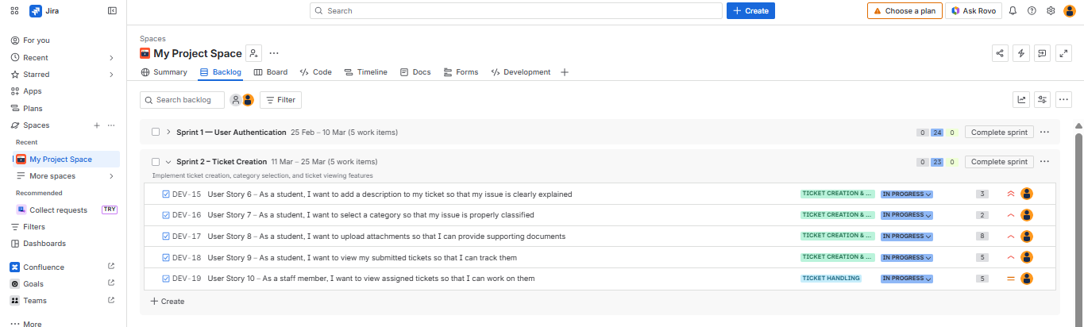

Sprint 3

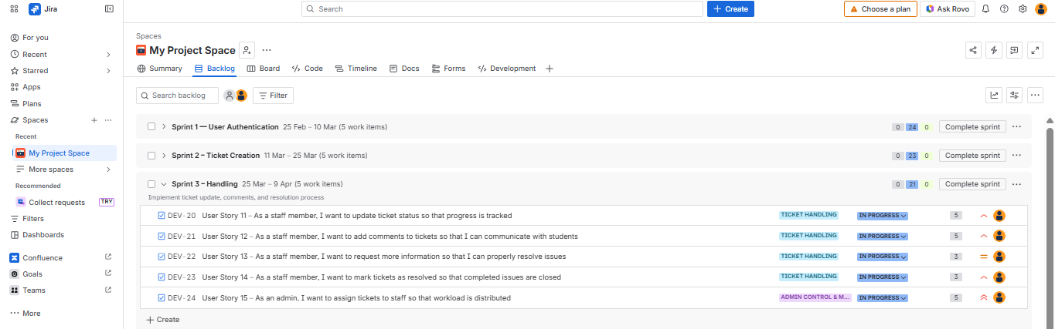

Sprint 4

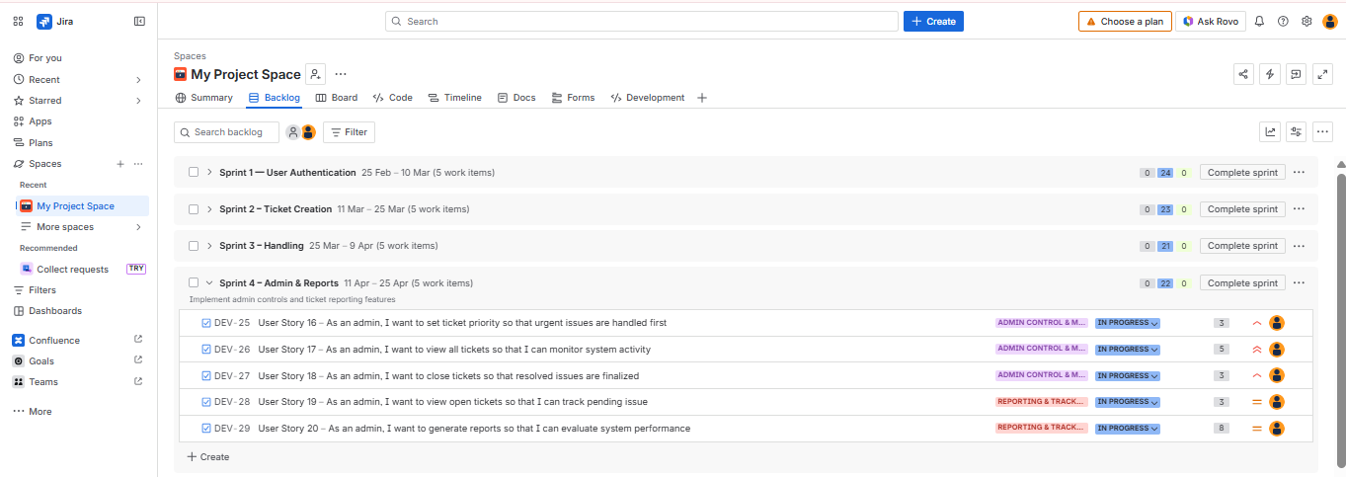

Result:
The Sprints are created for the Customer Support Ticket Management System Project.

EXP NO: 05
EXP NO: 5

POKER ESTIMATION USING JIRA

Create Epic, Features, User Stories, Task

Aim:
Create Poker Estimation for the user stories – Customer Support Ticket Management System Project.

Poker Estimation

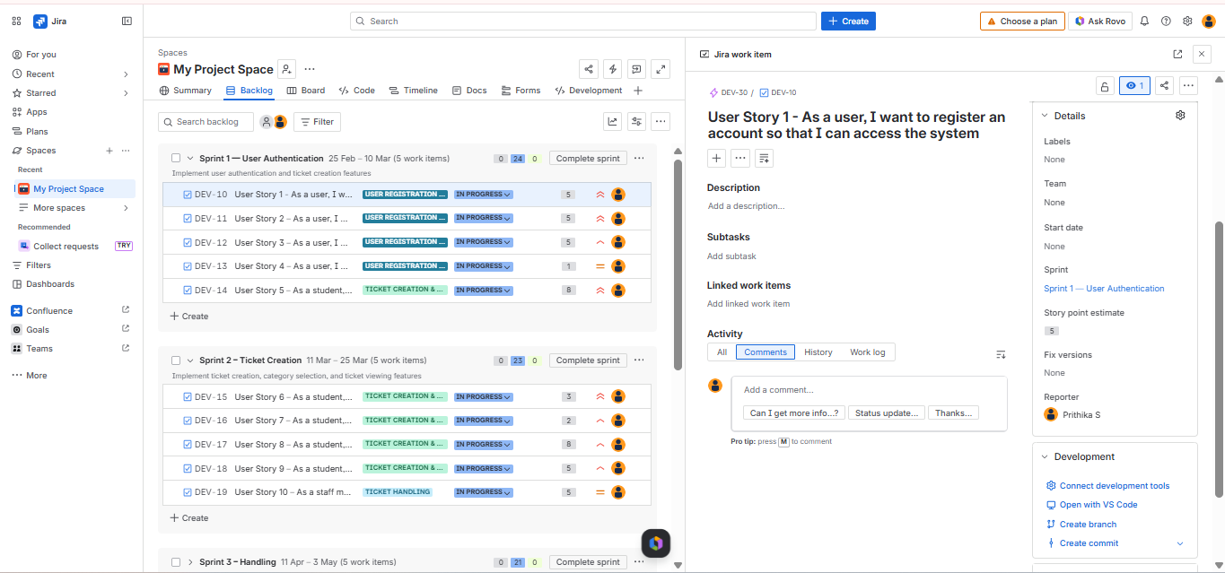

Result:
The Estimation/Story Points is created for the project using Poker Estimation.

EXP NO: 06
5EXP NO: 5EXP NO: 5EXP NO: 6
DESIGNING CLASS AND SEQUENCE DIAGRAMS FOR CUSTOMER SUPPORT TICKET MANAGEMENT SYSTEM

Create Epic, Features, User Stories, Task

Aim:
To Design a Class Diagram and Sequence Diagram for the given Project.

6A. Class Diagram

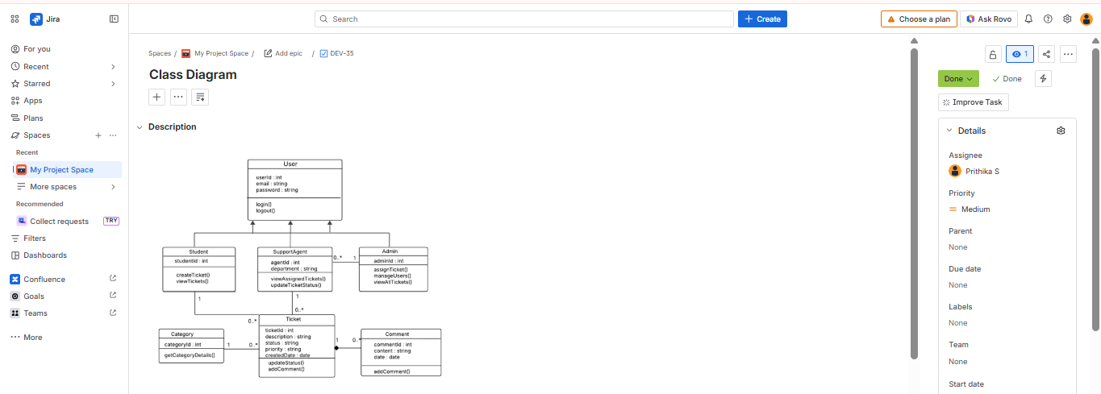

6B. Sequence Diagram

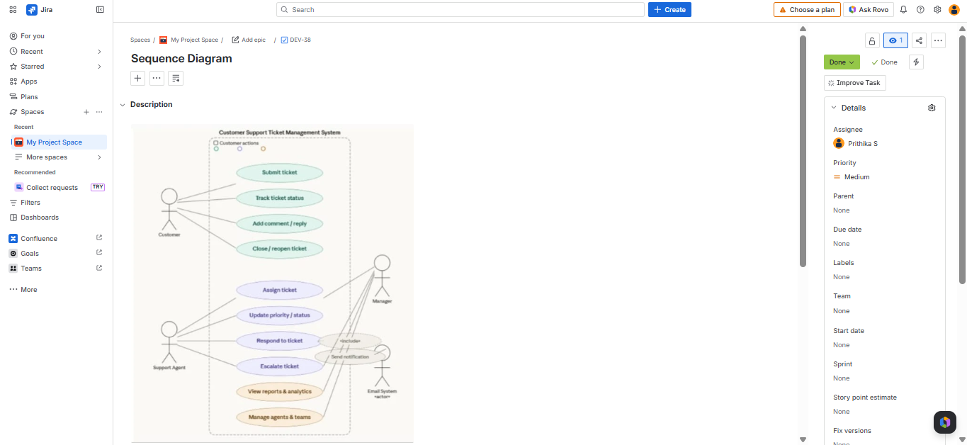

Result:
The Class Diagram and Sequence Diagram is designed successfully.

EXP NO: 5EXP NO: 5EXP NO: 5
EXP NO: 07

DESIGNING ARCHITECTURAL AND ER DIAGRAMS FOR CUSTOMER SUPPORT TICKET MANAGEMENT SYSTEM

Create Epic, Features, User Stories, Task

Aim:
To Design an Architectural Diagram and ER Diagram for the given Project.
7 A. Architectural Diagram

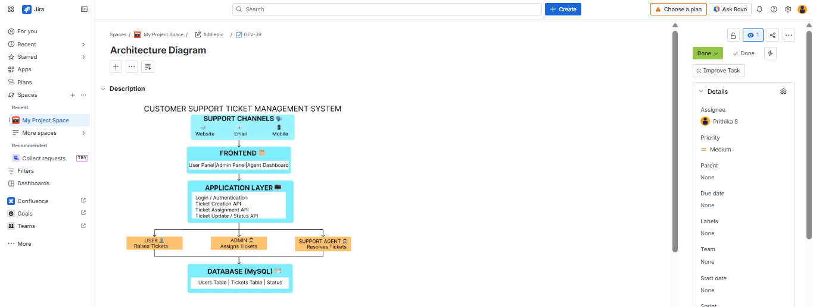

7 B. ER Diagram

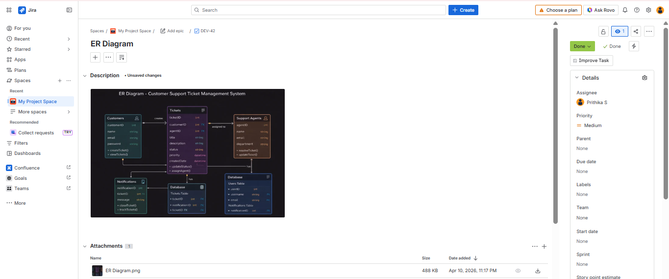

Result:
The Architecture Diagram and ER Diagram is designed Successfully .

EXP NO: 08

TESTING – TEST SUITES AND TEST CASES IN JIRA

Create Epic, Features, User Stories, Task

Aim:
To create Test plans and Test Cases, and write two test cases for atleast five user stories showcasing happy path and error scenarios in the jira platform.

Test Planning and Test Case
Test Case Design Procedure
- Understand Core Features of the Application
  - User Signup & Login
  - Create Support Ticket
  - View All Tickets
  - Track Ticket Status
  - Dashboard Overview
- Define User Interactions
  - Each test case simulates a real user behaviour (e.g., logging in, creating a ticket, tracking ticket status, viewing ticket.)
- Design Happy Path Test Cases
  - Focused on validating that all features function as expected under normal conditions.
  - Example: User logs in successfully, creates a ticket, and views ticket details.
- Design Error Path Test Cases
  - Simulate negative or unexpected scenarios to test robustness and error handling.
  - Example: Login fails with incorrect credentials, submitting ticket with empty fields, or invalid ticket ID.
- Break Down Steps and Expected Results
  - Each test case contains step-by-step actions and a corresponding expected outcome.
  - Ensures clarity for both testers and automation scripts.
- Use Clear Naming and IDs
  - Test cases are named clearly (e.g., TC01 – Successful Login, TC02 – Invalid Login).
  - Helps in quick identification and linking to user stories.

- Separate Test Suites
  - Grouped test cases based on functionality (e.g., Login Management, Ticket Creation, Ticket status tracking, Agent Response).
  - Improves organization and test execution flow in Jira.
- Prioritize and Review
  - Critical user actions are marked high-priority.
  - Reviewed for completeness and traceability against project requirements.

- Test suite
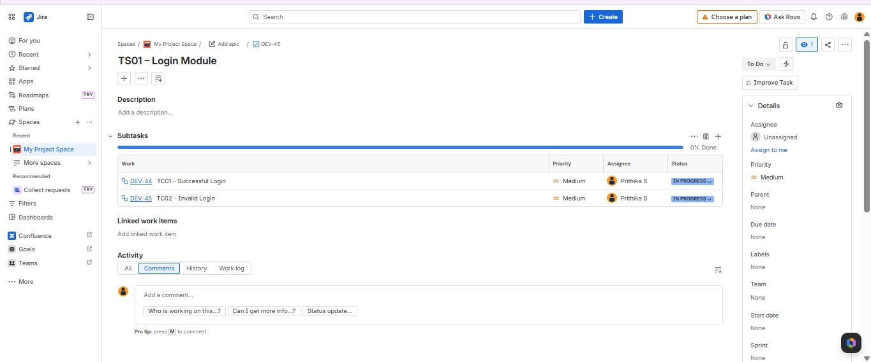
2. Test case
Give two test cases for at least five user stories showcasing the happy path and error scenarios in Jira platform.

USER STORIES
- As a user, I want to sign up and log in securely so that I can access the system (ID: US01).
- As a user, I want to register my account. (ID: US02).
- As a user, I want to track my order status using ticket ID (ID: US03).
- As a user, I want to view complete ticket details (ID: US04).
- As an admin, I want to view and manage all customer tickets (ID: US05).

Test Suites
Test Suit: TS01 – Login Module
- TC01 – Successful Login
  - Action:
    - Open login page.
    - Enter valid email and password.
    - Click "Login".
  - Expected Results:
    - Login successfull.
    - User redirected to dashboards.
  - Type: Happy Path
- TC02 – Invalid Login
  - Action:
    - Open Login page.
    - Enter invalid email or password.
    - Click on "Login".
  - Expected Results:
    - Error message “Invalid credentials” displayed.
  - Type: Error Path

Test Suit: TS02 – Ticket Creation
- TC03 – Create Ticket Successfully
  - Action:
    - Login successfully.
    - Click create Ticket and Enter valid title and description.
  - Expected Results:
    - Ticket created successfully.
    - Ticket ID generated and displayed.
  - Type: Happy Path
- TC04 – Create Ticket with Empty Fields
  - Action:
    - Login as user.
    - Click "Create Ticket" and Leave fields empty.
    - Click Submit.
  - Expected Results:
    - Validation message displayed.
  - Type: Error Path

Test Suit: TS03 – Ticket Assignment
- TC05 – Assign Ticket Successfully
  - Action:
    - Select a ticket and choose agent.
    - Click Assign.
  - Expected Results:
    - Ticket assigned successfully and agent name displayed.
  - Type: Happy Path
- TC06 – Without Agent
  - Action:
    - Select a ticket.
    - Click Assign without selecting agent.
  - Expected Results:
    - Message “Select an Agent” displayed.
  - Type: Error Path

Test Suit: TS04 – View Ticket Status
- TC07 – View Ticket Status Successfully
  - Action:
    - Login as customer
    - Open a ticket.
  - Expected Results:
    - Ticket details and status displayed.
  - Type: Happy Path
- TC08 – View Invalid Ticket
  - Action:
    - Open Invalid ticket ID.
  - Expected Results:
    - Message “Ticket not found” displayed.
  - Type: Error Path
Test Suit: TS05 – Agent Response
- TC09 – Successful Response
  - Action:
    - Admin enters response for a ticket.
    - Click Submit.
  - Expected Results:
    - Response saved and displayed in ticket details.
  - Type: Happy Path
- TC10 – Empty Response
  - Action:
    - Click Submit without entering response.
  - Expected Results:
    - Error message displayed.
  - Type: Error Path

3. Test Cases


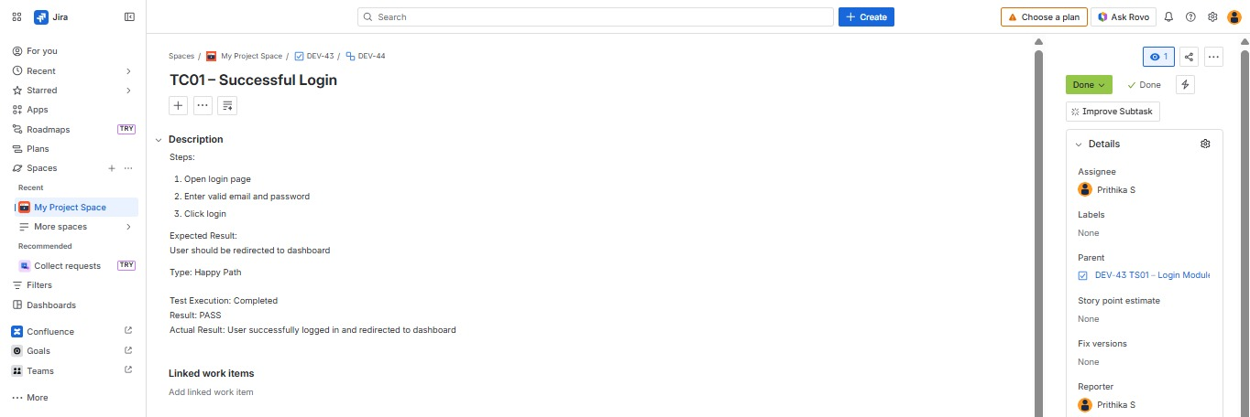

4. Installation of test (Apache JMeter)
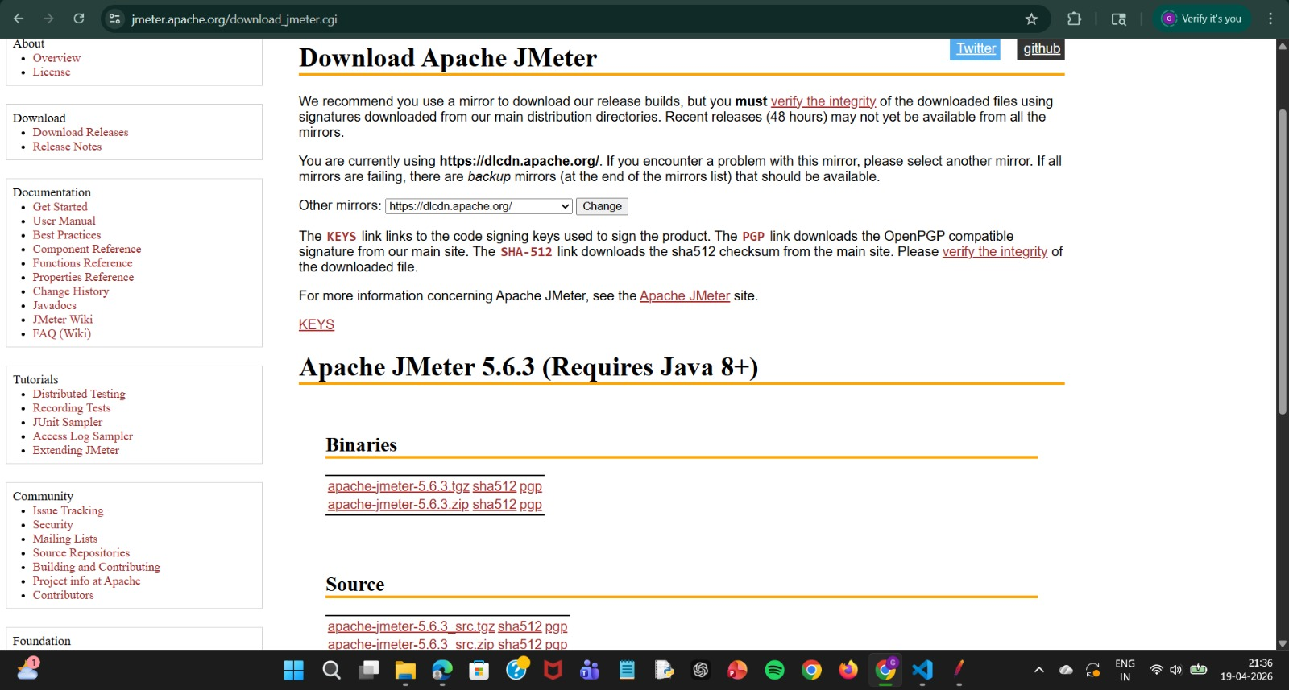
5. Test Plan

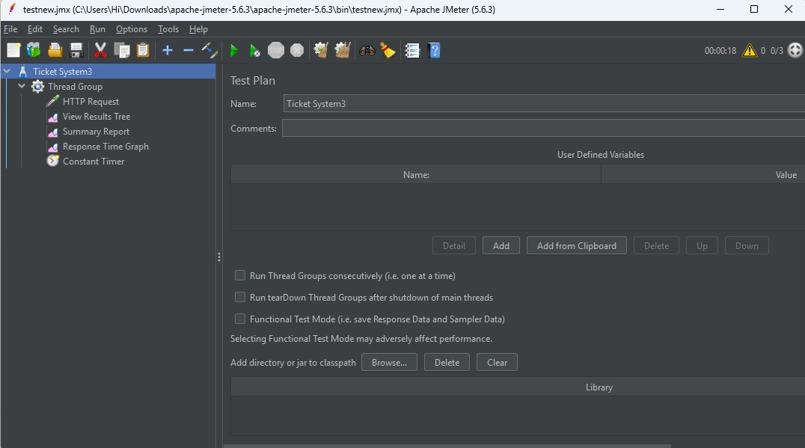

6. Creating the bug

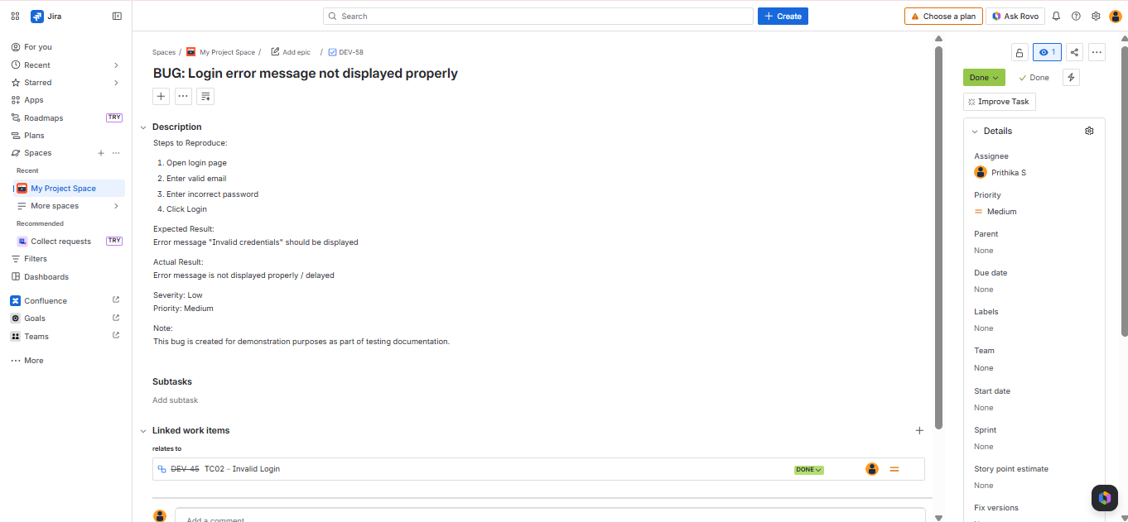

7. Response Time Graph
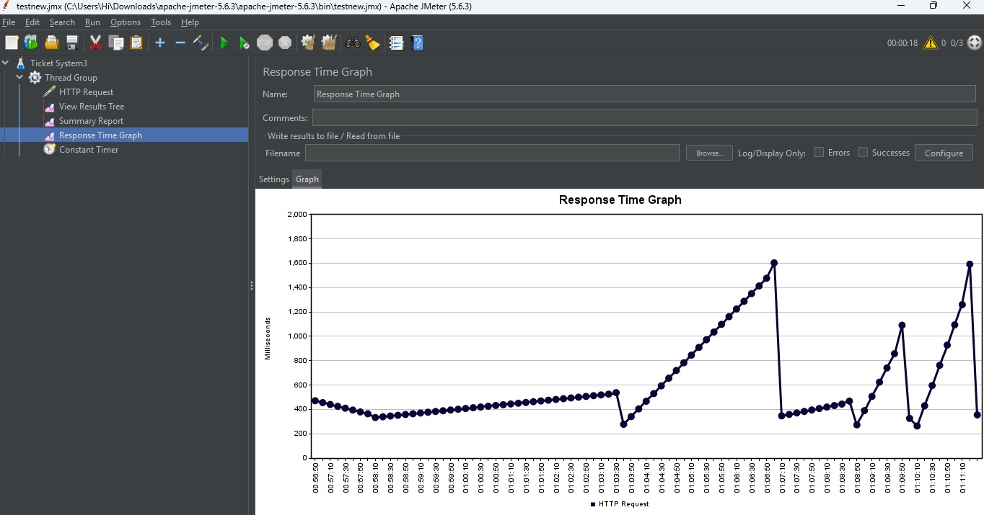

8. Summary report

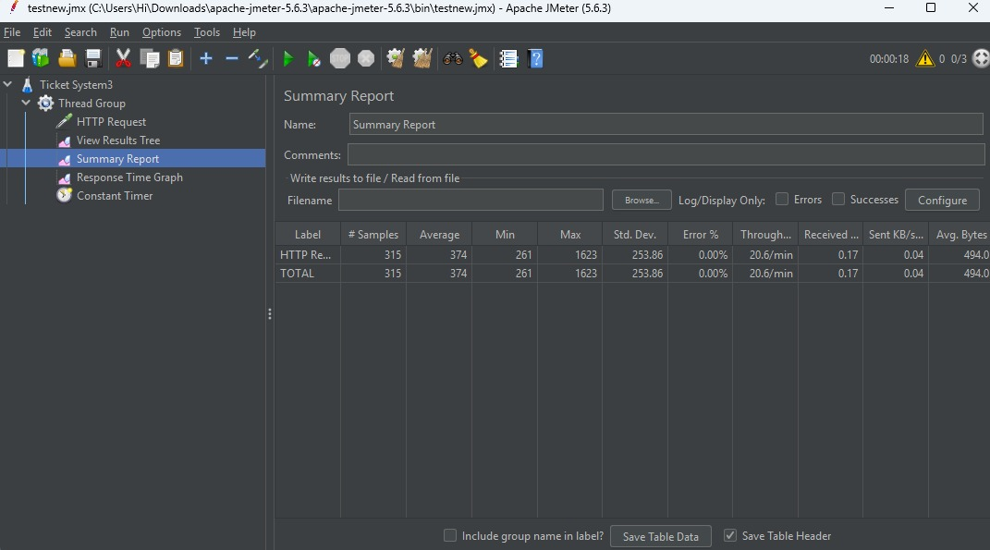

Result:
The test plans and test cases for the user stories is created in Jira with Happy Path and Error Path
.
EXP NO: 09

LOAD TESTING AND CI/CD PIPELINE SETUP

Create Epic, Features, User Stories, Task

Aim:
To perform load testing for the Customer Support Ticket Management System and to create and demonstrate a CI/CD pipeline using git hub action for automating application builds, tests, and deployment .

Load Testing
Load Testing:
Load Testing is used to simulate multiple users accessing the application simultaneously to evaluate system performance, response time, and stability under heavy traffic. It helps identify bottlenecks, and improve scalability before deployment.

Steps to Perform Load Testing:
- Sign in to the selected load testing tool (Apache JMeter / Locust / online load testing tool).
- Create a New Test Plan
  - Open the tool and create a new test plan.
- Configure Thread Group
  - Number of Users: Enter virtual users.
  - Ramp-Up Time: Set user start time.
  - Loop Count: Set number of requests.
- Add HTTP Request
o Server Name: localhost / deployed server IP.
o Port Number: 3000
o Path: /
- Add Listeners
o View Results Tree
o Summary Report
o Graph Results
- Save the test plan and click Start.
- Observe performance metrics such as:
o Response time
o Throughput
o Error percentage
o CPU usage

Steps to Create and Demonstrate CI/CD Pipeline:
- Open GitHub repository containing the Customer Support Ticket Management System source code.
- Open GitHub Actions / CI-CD tool.
- Create a new workflow file.
- Configure pipeline stages:
  - Build React application using npm
  - Run test cases
  - Build application
  - Display Build Access
- Save the workflow file.
- Trigger the pipeline by pushing code changes.
- Verify successful build, test, and deployment status.

Load Testing
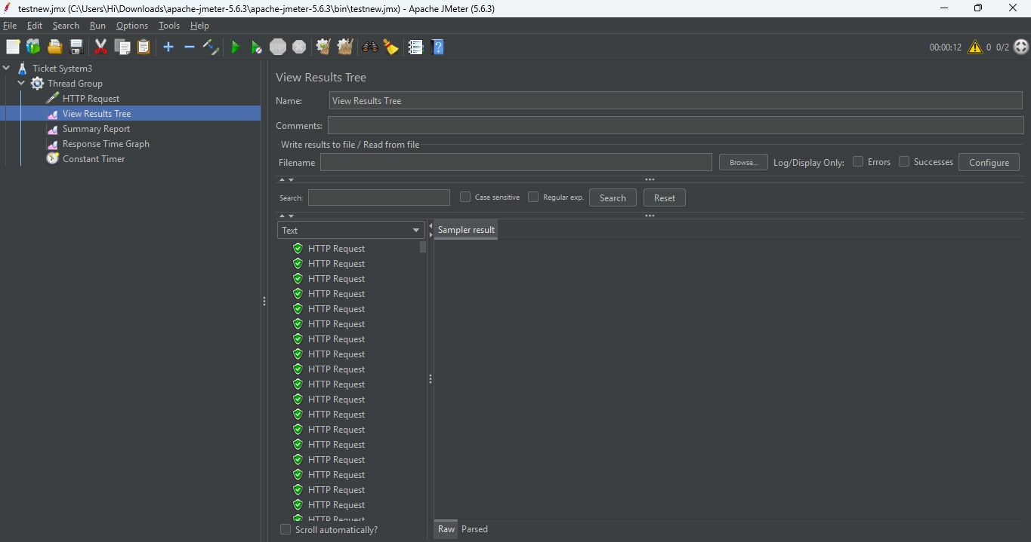

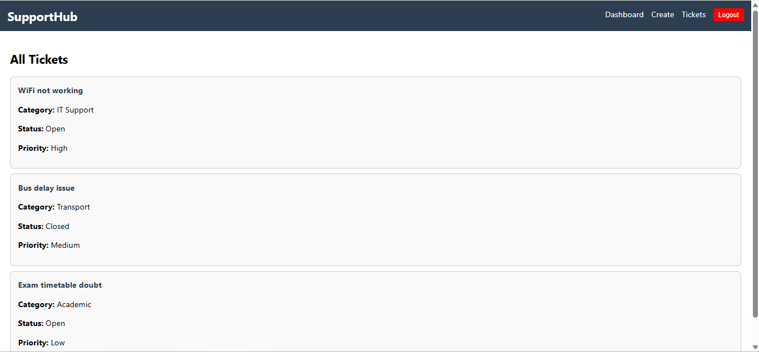

Pipelines

Description:
This experiment demonstrates how to connect a GitHub-hosted React-based Customer Support Ticket Management System project with Jira. The pipeline automatically installs dependencies, installs dependencies, builds the React application, and verifies execution. This ensures every code commit is verified for reliability and smooth deployment.

Steps:
- Connect GitHub Jira:
  - Open Jira project settings.
  - Select GitHub integration.
  - Authorize access to your GitHub repository.
  - Link the repository with the Jira project.
- Create GitHub Actions Workflow:
  - In your GitHub repository, open Actions tab.
  - Create a new workflow file inside:
.github/workflows/main.yml
- Add Pipeline Configuration:
o Configure Node.js setup.
o Install dependencies using npm.
o Build React application
o Run basic checks.
o Display Success message.
- Commit and Push Code:
o Push changes to GitHub repository.
- Automatic Pipeline Execution:
o GitHub Actions automatically starts pipeline after each push.
- Verify Results:
o Check build success, test results, and deployment status.

Main.yml code
name: React CI Pipeline

on:
push:
branches:
- main

jobs:
build:
runs-on: ubuntu-latest

steps:

# Step 1: Checkout code
- name: Checkout Repository
uses: actions/checkout@v4

# Step 2: Setup Node.js
- name: Setup Node
uses: actions/setup-node@v4
with:
node-version: '18'

# Step 3: Install dependencies
- name: Install Dependencies
run: npm install

# Step 4: Build React App
- name: Build App
run: npm run build

# Step 5: Success Message
- name: Display Message
run: echo "Customer Support Ticket System Build Successful!"

- Pipeline Tasks Include:
- Setting up node.js environment .
- Installing project dependencies using npm.
- Building react application.
- Running basic checks for functionality.
- Displaying a success message after successful pipeline execution.
- Run and Monitor Pipeline:
- Commit changes to the main branch of your GitHub repository to trigger the pipeline automatically.
- Open the GitHub Actions tab to monitor workflow execution.
- View logs, build status, test results, errors, or success messages and ensure the pipeline runs successfully.

Pipeline

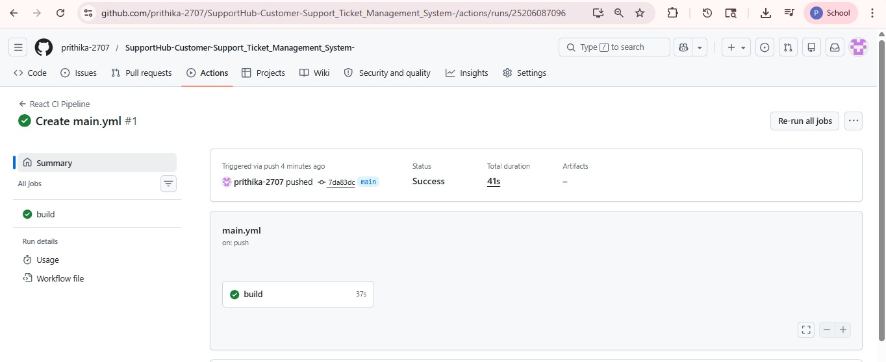

Result:
Successfully created the Load Testing resource and executed a load test to assess the performance of the specified endpoint and also demonstrated pipelines in Jira.
EXP NO: 10

GITHUB: PROJECT STRUCTURE & NAMING CONVENTIONS

Create Epic, Features, User Stories, Task

Aim:
To provide a clear and organized view of the project's folder structure and file naming conventions, helping contributors and users easily understand, navigate, and extend the Customer Support Ticket Management System project.

GitHub Project Structure

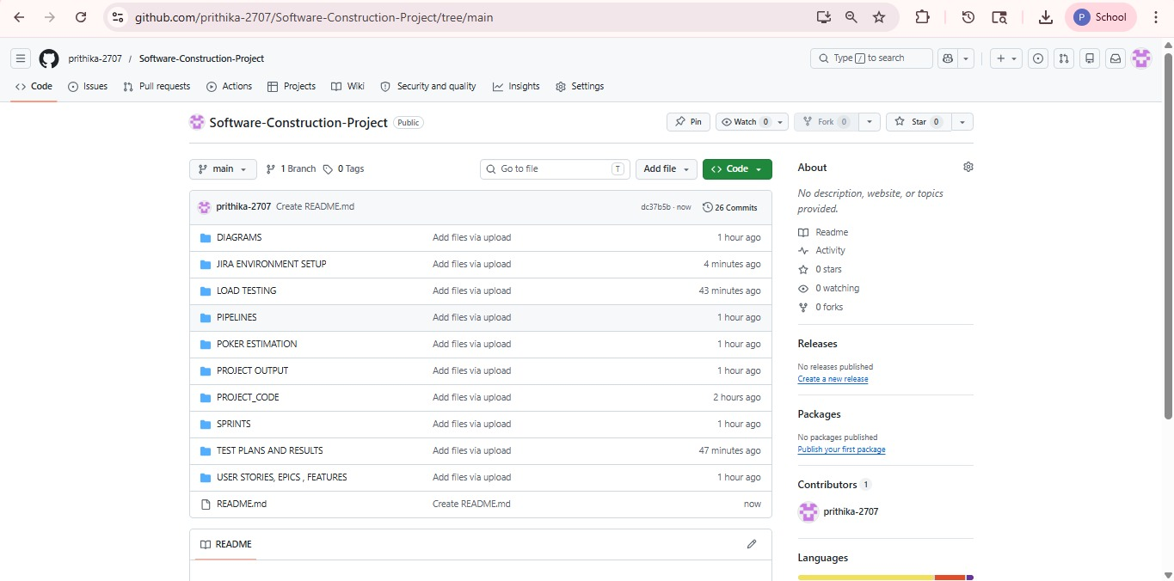

Result:
The GitHub repository clearly displays the organized project structure and consistent naming conventions, making it easy for users and contributors to understand and navigate the codebase.

